# ARP Spoofing Attacks (Deliverables)

Implementing ARP Spoofing:

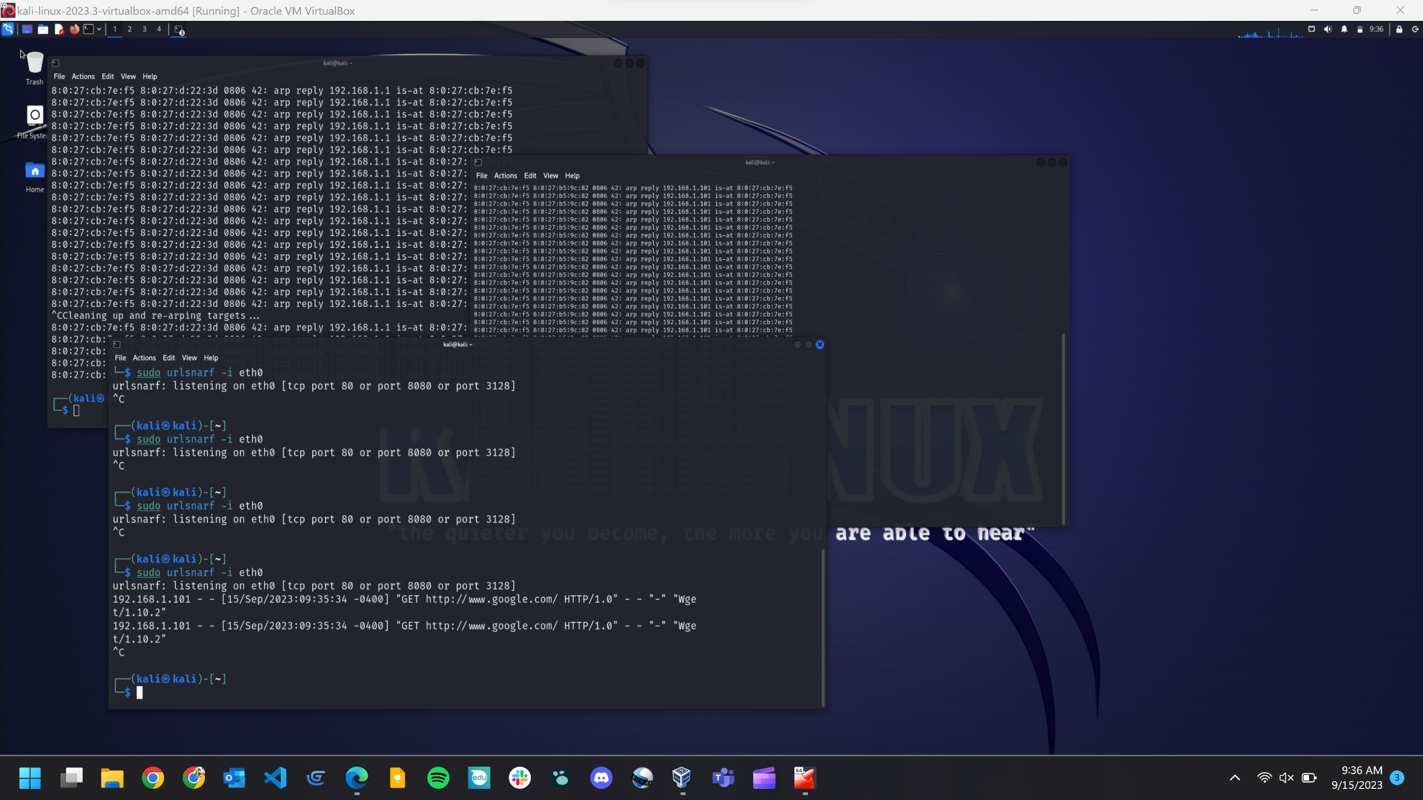

Python Code Working:

(Code Shown Below)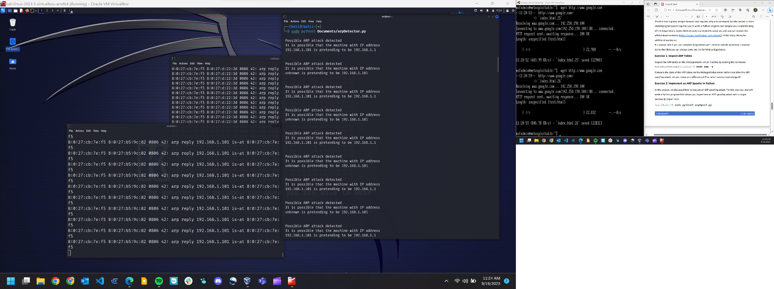

## Exercise 1: Inspect ARP Tables

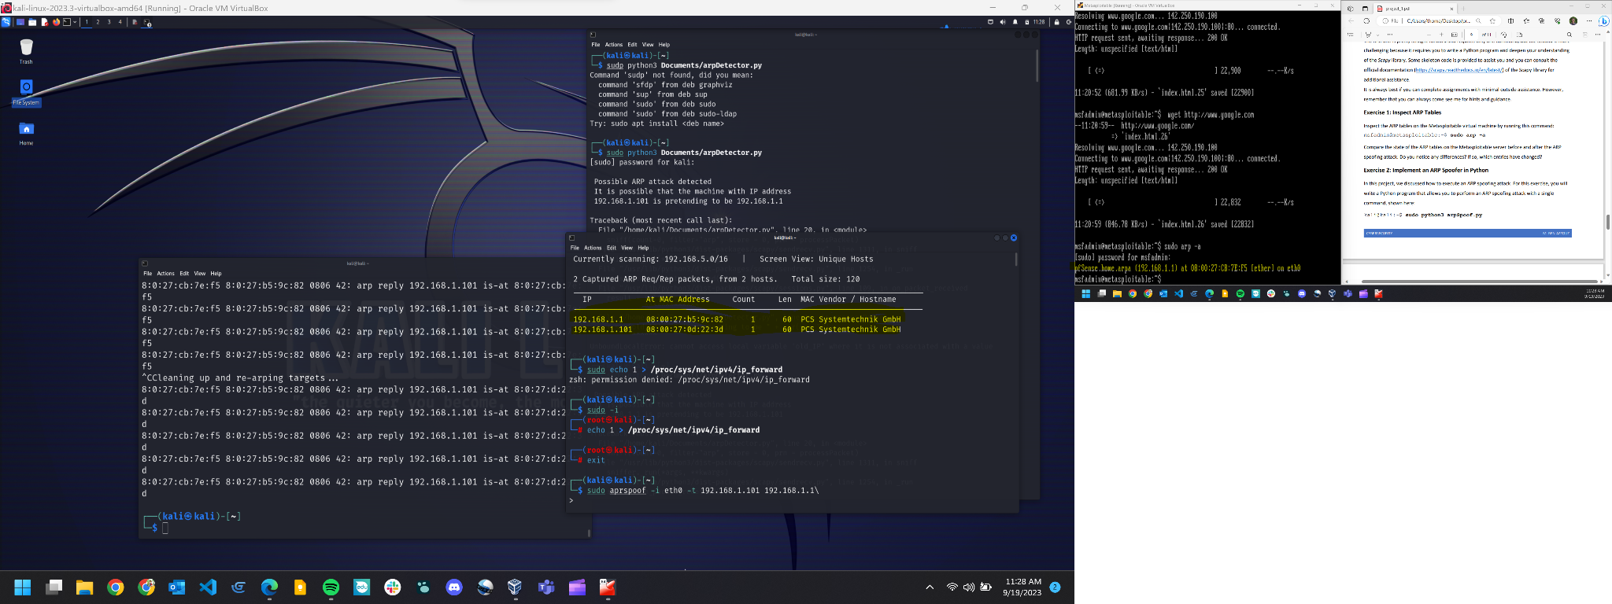

## Exercise 2: Implement an ARP Spoofer in Python